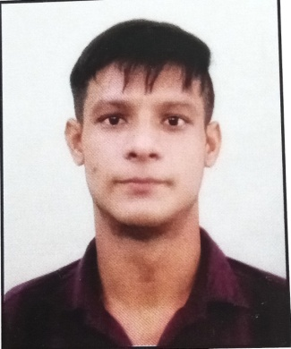
RAY SAHAB DAGER
FRONT-END-Graphics Designer

https://www.finewebmedia.com(Ghaziabad)
https://www.pradyumnainfotech.in(Ghaziabad)http://www.getkart.in (Delhi) https://www.pickzon.com (Delhi) https://digiindiasolutions.com(Delhi)

- 10th from Lakshya High School Chhata Mathura, (U.P) (2014)
- 12th from Janta Inter Collage Chhata Mathura, (U.P) (2016)
- B.A Form Dr Bhimrao Ambedkar Agra University(U.P) (2017)

- B.com from M.M.H college Ghaziabad (U.P)
- M.com from M.M.H college Ghaziabad (U.P)
- MCA from Punjab Technical university Jalandhar
Reading Books
Getkart (PickZon.com) PVT LTD In Delhi
https://www.pickzon.com
WORKING AT TIME

Matters of religious knowledge
«›
Music
«›
«›
HOBBIES
«›
Tigaon Faridabad Haryana 121101
«›
+91- 7827792316
«›
Sahabray585@gmail.com
CONTACT

Graphics Designer and Html, CSS, Photoshop, illustrator, Canva, Seo, photopea
EDUCATIONAL QUALIFICATION
PROFILE

Linkedin Profile
https://www.linkedin.com/in/ray-sahab-dager
Portfolio Profile
https://www.behance.net/rajudager
PERSONAL INFORMATION

- NAME: : RAY SAHAB
- FATHER NAME: NATTHI RAM
- DOB: 10 JULY1998

WORK STATUS

https://pradyumnainfotech.co.in (Ghaziabad) (JUN 2017 to December 2018)
https://www.finewebmedia.com (Ghaziabad) (January 2019 to November 2020)
https://getkart.in (Delhi) (December 2020 to December 2021)
https://www.pickzon.com (Delhi) (January 2022 to December 2023)
https://www.digiindiasolutions.com (Delhi) (December 2023 to May 2024)

React JS project
- https://www.pickzon.com/

Magento Projects
- http://www.getkart.in

EXPERIENCE SUMMARY

Date ………………………….(Ray Sahab)
Place …………………………

