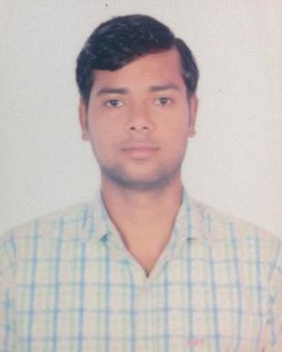
Amit Kumar Nain
House No-114 A Marketing Board Colony,
Sector-14, Panchkula (134113)
nainamit0@gmail.com
+918950242236

Objective
To succeed in an environment of growth and excellence and earn a job which provides satisfaction and self-development and help to apply knowledge to achieve organizational and Personal Goals.

Qualification
Sr.No | College/University | Degree | Marks | Year
1. | Seth Jai Parkash Mukand Lal Institute Of Technology, Radaur | B-Tech (CSE) | 68.42% | 2015
2. | Government Polytechnic Ambala City | Diploma (CSE) | 61.47% | 2012
3. | Manav Mangal School, Panchkula | Matric | 67.8% | 2009

Key Skills
- Data Reporting
- Quality Analysis
- Client Handling
- Business Communication/Process Mapping
- Project Management
- Project implementation
- Research/Reporting
- Mentoring and Training

Technical & Key Skills
- Relational database knowledge, strong spreadsheet proficiency and analytical skill-set
- Detail oriented with a strong ability to multi-task and work under pressure in a fast paced environment
- Ability to build professional networks; knowledge of company's strategic direction and strengths and weakness
- Strong organizational skills, attention to detail, time management skills, ability to manage many tasks simultaneously while meeting critical deadlines
- Able to provide quality assurance and comfortable questioning members of business and change team
- Proficiency with Microsoft Office applications, including the ability to create graphs and tables using Excel
- Excellent verbal and written communication skills, underpinned by solid analytical and problem solving ability
- Demonstrated ability to think on your feet and make good decisions

Experience
Publicis Groupe : Data Governance Specialist : August 2021 – Till Date
Key responsibilities
• SME for DG Processes, automation/optimization and other Project Management Tracks like Training, Recruitment, Engagement.
• Along with the role of the DO for his/her track, TL does the following additional tasks/ activities -
• First Point of Esclation for Client Team
• Onboarding new accounts.
• Identifying scope of automation/optimization.
• Process refresher and reinforcement sessions
• Owning EYP for DO
• Work Transitions
• Account, Scope of Work Audit
• O3 effectiveness
• Reviewing Weekly Reports sent by DOs and take actions accordingly

Google: GEDI/Merchant Promotion : August 2015 – August 2021
Key responsibilities
- Maintain quality of catalog that includes creating new catalog, correction of titles, scrubbing of products
- Review the rejected items to resolve the issue through various methods.
- Generating team performance report.
- Managed the plan implementation and delegated task to team members.
- Presented findings and data to team to improve strategies and operation.
- Quality Analysis and Training sessions.
- Interaction with clients to understand their requirement and provide best possible solution.
- Supporting internal advisors with business development, new client opportunities and client meetings.
- Publishing Weekly/Monthly Reporting.
- Creating and giving Power Point Presentation to internal and external clients.
- Monthly calls with Client on risk management associated with data.
Key Accomplishments:
- Implemented next-generation Google catalog with association with the leadership team.
- Successfully handled a New process which came in a shopping season and later on became the very crucial process.
- Star performance award given by company 9 times.
Extra Curricular Activities
- Stood 2nd in Haryanvi Skit an event held during Enchante 2K14.
- Participated in Inter College Cricket Tournament.
- Awarded 6 Months Certificate Diploma in Software Usage.
Strengths
- Leadership
- Listening
- Responsible
- Quick Learner

Hobbies
- Listening to Songs
- Online Gaming
- Exploring new places
- Playing Cricket

Personal Details
- D.O.B - 7th September 1993
- Languages Known – HINDI, ENGLISH, PUNJABI
- Alternate Contact No. – 08950242236
- Alternate Email id – nainamit0@gmail.com

I hereby declare that the information furnished above is true to the best of my knowledge.

(Amit Kumar Nain)

.

