NAME : CHINGSUBAM ABINASH SINGH 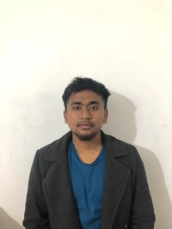

ADDRESS : LALAMBUNG MAKHONG TAKHELLAMBAM LEIKAI IMPHAL WEST, 795001

Email:abinashsingh11944@gmail.com

Phone: 8073099813

Objective

An opportunity to improve professional qualities while contributing to the symbolic growth of the organization with my technical, logical skills.

Soft skills

Proficient in speaking Hindi, English, Manipuri, Nepali

Friendly

Leadership

Teamwork

Education
EDUCATION | INSTITUTION | BOARD/UNIVERSITY | YEAR  OF PASSING | SCORE
B.C.A | REVA university | Autonomous  university | 2020 | 6.83 CGPA
12thstd. | Enlighten knowledge higher sec. school | Manipur Board | 2016 | 56%
10th | K.V lamphel school | CBSC | 2014 | 7.2 CGPA

